

**Executive Summary**

**Creating a usable Python program for Walton AMP data users**

**By**

**Venkat Subramanian & William Martens**

December 10th, 2018

ISYS 5103

# **Introduction**

In a 2006 article that appeared in the Harvard Business Review, Thomas Davenport of Babson University argues that because product and price competition have increasingly intensified globally, companies must begin to differentiate their business processes in order to gain an advantage. Davenport believes the key to differentiating one’s business process is through analytics: those that effectively use analytics “wring every last drop of value from those processes” (2). By using analytics, companies are able to determine and predict customer behavior, manage inventories more effectively, and make more informed HR decisions (2).

The purpose of this project is to give the Walmart AMP organization a Python analytics program that increases the value of its business processes. Using data made available to us by the Walton College, our program is designed to extract and present information, insights, and trends to AMP employees and management for the purposes of process improvement and differentiation.

## **The Problem**

The data in its current form is relevant and extensive but requires transformation and manipulation in order to be rendered useful by management. Valuable information about the AMP’s customers and its core business exist in the data, but management does not have a way to see this information at a high-level, decision-informing view.

## **The Solution**

Our intent is to create a Python program that transforms the data into a useful decision making tool and presents it in a readable, user-friendly way. The program performs basic data transformation functions to convert the data into usable information. By using various modules, libraries, and packages, the program reads queried data and produces high-level descriptive statistics and visualizations to aid management in decisions related to strategy formulation, marketing efforts, and business partnerships. We identified 4 major business questions our program will help answer:

1. How much net income does the AMP earn every year?
2. What are the AMP’s highest and lowest grossing concerts every year?
3. How much net income comes from ticket sales and how much comes from fees?
4. What kind of tickets are customers buying?

# **Background**

## **The Walmart AMP**

Since finding its permanent location in 2014 at Rogers, the Walmart AMP has become NWA’s premiere music venue. The AMP began in 2005 in the Northwest Arkansas Mall parking lot as a temporary performance venue and was acquired by the Walton Arts Center in 2011. As demand for musical entertainment grew, the Walton Arts Center realized the need for a permanent structure and, after a brief stint at the Washington County Fairgrounds, the AMP found its home in the bustling town of Rogers. The new AMP is an amphitheater - one of the top 100 in the country - and has a capacity just over 9,500, which includes 3,200 covered seats and sprawling lawn general admission (*waltonartscenter.org/AMP*).

While the AMP initially struggled to attract the industry’s biggest performers, its reputation has grown and popular acts are beginning to see the profit potential in Midwest areas like Northwest Arkansas (VanAuken, personal interview). Over the past three years, popular artists like Kid Rock and Journey have performed at the venue, legitimizing its existence as a big-play concert venue.

## **The Data**

The dataset that our program uses was provided to us by the Walton College in partnership with the Walmart AMP. The dataset, labeled “transactions,” includes transaction details for every ticket or group of tickets purchased from the AMP for the fiscal years 2015-2017. A data dictionary for the table is provided below:

**Figure 1: Data Dictionary**

|  |  |  |
| --- | --- | --- |
| **Variable Names** | **Variable Description** | **Example Values** |
| customer_no | Unique numerical customer number | 67479 |
| fyear | Fiscal year of performance | Range: 2015-2017 |
| genre | The artist's or group's genre | Rock', 'Pop', 'Comedy' |
| group_desc | Description of the artist or group | Avett Brothers FY15' |
| income_amount | Amount of income earned for the transaction in dollars | Range: 0 - 49,703 |
| mos_id | Unknown | NA |
| order_dt | Date of ticket order | 24JUL14:15:47:53 |
| order_no | Unique ticket order number | 1401031 |
| perf_code | Unique text performance code | AVETTFY15 |
| perf_dt | Date of performance | 26SEP14:20:00:00 |
| perf_no | Unique numerical performance codes | 11155 |
| pmt_method | Type of payment used by customer | Visa', 'Mastercard', 'Cash' |
| pmt_method_id | Unique numerical string to identify payment method | 63 |
| price_category | Type of income or refund | Ticket Price' or 'Fee' |
| price_type | Type of ticket | Regular', 'Pre Sale', 'Fan Club' |
| price_type_id | Unique numerical string to identify price type | 1 |
| refund_amount | Amount of refund given for the transaction in dollars | Range: -5,900 - 0 |
| trn_dt | Date of ticket transaction | 24JUL14:16:09:14 |

**Comments about the data:**

* The AMP’s fiscal years do not align with the calendar year. Thus, all performance dates are one year behind their respective fiscal year date (i.e. a performance in fiscal year 2015 actually occurred in 2014).
* There were over 30 different ticket price types.
* There were also over 30 different payment methods.

# **The Program**

## **Design**

Our application has a client server architecture. We have used python to develop the front end (using tkinter). Sqlite is the database we are using. The technology stack is given in Figure 3.

Below is a diagram depicting the UI design flow of our program:

**Figure 2: Program Design Flow**

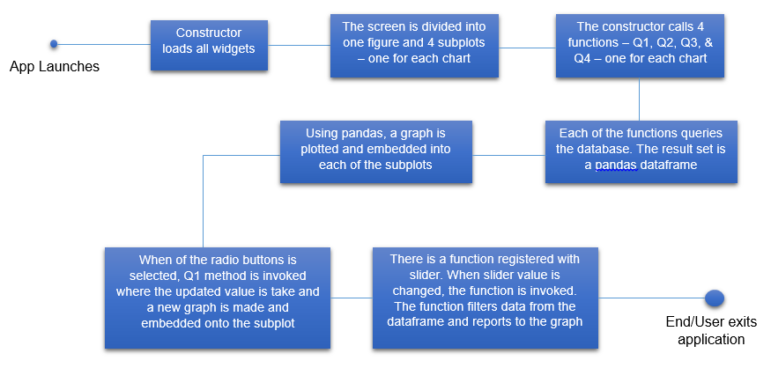

## **Figure 3: Program Design Flow**

 - Front end, logic

 - For charting, embedding the plots into tkinter

 - For charting, getting dataframe out of the resultset of sql.

 - backend database.

Below are depicted the tables in wamp database dump. Current tables are not linked and for the purpose of this exercise only data from **transactions** table alone is used.

Also note that the data in the below tables was given as .csv files by WAMP. The csv files were imported into sqlite database using sqlitestudio. Currently, the tables are not linked by any referential integrity.

**Figure 4: Program Design Flow**

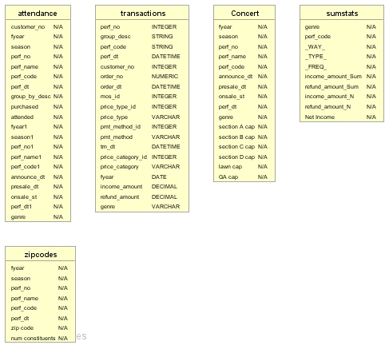

## **Requirements & Assumptions**

1. It is assumed that python and pip are installed in the system. If not please install them.
2. The entire application code is in one script (wamp.py), which will be part of the deliverable.
3. There are some packages that the application depends on: **pandas**, **matplotlib** and **sqlite3**.
4. We have tested this application in Windows only.

## **Instructions**

1. Download the deliverables zip file.
2. Unzip the contents in the deliverables folder into any directory.
3. Move the sqlite folder (from inside the deliverables folder) into directly under C Drive. After this you should see this folder structure: **c:/sqlite/databases**.
4. Run the below pip statements:

**pip install pandas**

**pip install matplotlib**

**pip install sqlite3**

1. Run wamp.py script.

## **The Output**

The execution of our Python program results in a data dashboard that provides answers to our 4 primary business questions:

**Figure 3: Program Output**

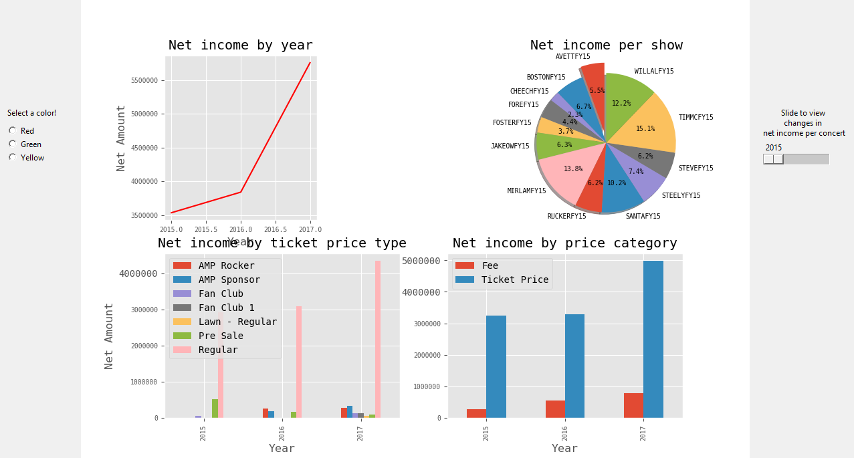

**Static visualizations**

* **Upper left corner:** This line graph shows the total net income for the AMP for fiscal years 2015-2017.
* **Bottom left corner:** This clustered bar chart depicts total net income for the AMP for fiscal years 2015-2017, grouped by ticket price type. The query only returns those ticket price types that had net incomes greater than $50,000. There were about 30 different ticket price types and we found that putting the $50,000 filter still gave us about 98% of all net income for a given year and cleaned up the cluttered look.
* **Bottom right corner:** This clustered bar chart depicts total net income for the AMP for fiscal years 2015-2017, grouped by price category (Ticket Price vs. Fee).

**Dynamic visualizations**

* **Upper right corner:** This pie chart shows the total net income for the AMP, broken down by the percentage of revenue that each concert earned. A slider bar appears to the right of the graph that enables users to slide between 2015, 2016, and 2017.

# **Results & Recommendations**

Our Python program returns some insightful trends that we believe will help management to plan and forecast for future years. We discuss the results and make recommendations to management within the framework of our 4 primary business questions.

1. **How much net income does the AMP earn every year?**

We note that fortunately for the AMP, total net income has been increasing every year. Net income increased a modest 8.6% from 2015($3.53M) to 2016($3.83M) and increased a hefty 50% from 2016 to 2017($5.75M). Such large net income increases, while desired, are unusual. Thus, we recommend that management take a deeper look at 2017 operations to discover any obvious reasons for the large increase. We suspect that management may be able to find a few factors or best practices that might help them to achieve a similar growth for the next year.

1. **What are the AMP’s highest and lowest grossing concerts every year?**

For 2015, we can see that the highest grossing concert was TIMMCFY15 (Tim McGraw) at 15% of total net income and the lowest grossing concert was CHEECHFY15 (Cheech & Chong) at 2.3%. Interestingly, the top 3 concerts in 2015 were all country concerts. The highest grossing concert for 2016 was KIDROCK16 (Kid Rock) at 15.7% of total net income and lowest grossing concert was WHITEFY16 (Whitesnake) at 4.2%. Finally, for 2017, the highest grossing concert at 10.8% of total net income was JOURNEY17 (Journey and The Doobie Brothers) and the lowest grossing concert was WIDESPR17 (Widespread Panic) at 2.3%. There does not seem to be any one type of music that customers consistently are willing to pay more for. We recommend that management continue to book a variety of concerts and continue to look for any trends related to the type of genre.

1. **How much net income comes from ticket sales and how much comes from fees?**

As the clustered bar graph indicates, the majority of the AMP’s net income comes from ticket sales. However, we can see that between 2015 and 2016 the difference in total net income was largely attributable to the increase in fees - ticket price net income did not increase very much. Nonetheless, we recommend that the AMP continue to focus on increasing ticket price revenue because it is the main driver of overall net income.

1. **What kind of tickets are customers buying?**

As previously mentioned, the results were filtered to include only those ticket price types that had net incomes above $50,000. We see that Regular ticket sales overwhelmingly accounted for the majority of the AMP’s income in all three years. Other interesting observations include the decline in Pre Sale ticket income and the rise in AMP Sponsor and AMP Rocker ticket revenue. We suggest that management investigate the reason for the decline in Pre Sale ticket revenue as well as promote the AMP Sponsor and AMP Rocker packages to more corporations in the area.

# **Conclusion**

Companies are beginning to develop their core businesses as processes built on the ability to collect, analyze and interpret data (Davenport, 2). We believe that in order for the Walmart AMP to continue to grow and compete in the live performance industry, increased use of data analytics is necessary. Our Python program is a first step for the AMP in developing an analytics toolkit and will help management assess the health of its business, identify areas that need improvement or redesign, and plan for future business strategies.

**Works Cited**

“About.” *Waltonartscenter.org/AMP*, <https://waltonartscenter.org/AMP/about/about-us/>. Accessed 8 Dec. 2018.

Davenport, Thomas H. “Competing on Analytics.” *Harvard Business Review.* Jan. 2006. <https://hbr.org/2006/01/competing-on-analytics>. (link to online version)

VanAuken, Bryan. Personal Interview. 17 Nov. 2018

Bryan is the head of sound and production at the AMP and also the head sound guy at the church I attend. The information I included in this report is from a conversation I had with him about the project I was completing related to the AMP for ISYS 5503.